Technical Design Document (TDD)

**Around the World**

Group 3: Team TFA

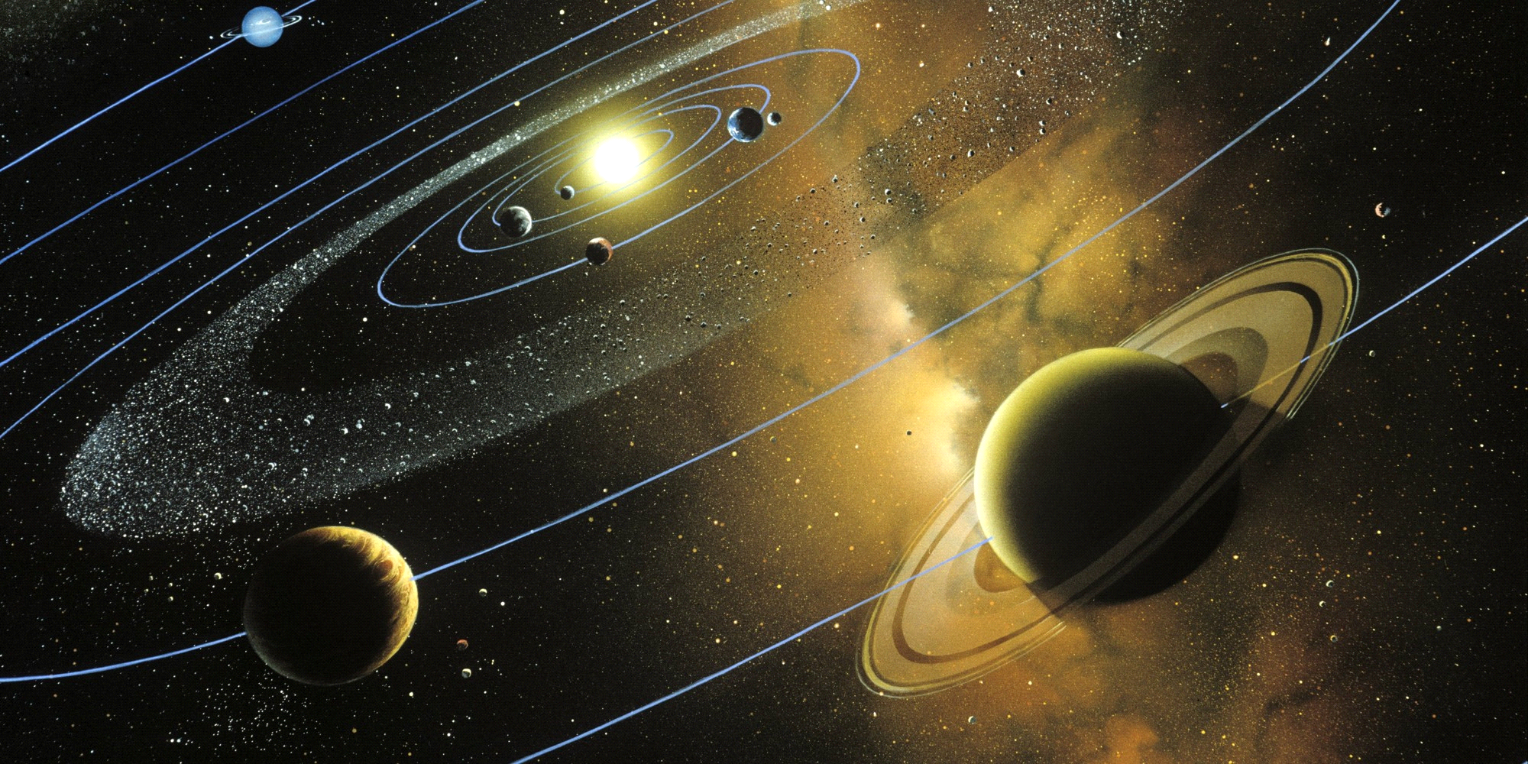

Version: 1

Created: 8/27/2015

Last Updated: 8/28/2015

**Table of Contents**

Executive Summary 3

Project 3

Technical 3

Programs 3

Market Release 3

Time to Completion 3

Estimated Cost of Completion 4

Hardware and Software 5

2D Software 5

Sound Software 5

Programming Software 5

Development Plan 6

Milestones 6

Project Goals 6

Features 6

File Formats 8

2D 8

3D 8

Audio 8

Scripts 8

Scenes 9

Other 9

Asset List 10

Audio 10

Executive Summary

**Project**

Around the World is a 3D space game where the player controls a spaceship that can fly around the solar system. Populating the solar system are the Sun, the Earth, the other planets and Earth's moon. The goal for the player is to navigate among these obstacles, avoiding any collisions, while also not venturing too far away from the Sun. If the player's spaceship collides with the Sun or a planetary object, or moves too far from the Sun, the spaceship is destroyed. At that point, the player is given the choice of playing again or quitting the game. The player can affect the difficulty of the gameplay by adjusting numerous parameters, such as the speed of the planetary objects or of the spaceship...making navigation easier or harder. Naturally, the player is prevented from inputting incorrect parameter values that might result in unplayable scenarios or physically impossible simulations (such as planets counter-rotating around the sun).

### Technical

Programs

The following programs will be required for the creation of Around the World:

|  |  |  |
| --- | --- | --- |
| Program | Purpose | Cost |
| Unity3d | Game Development Environment | $4,500.00 |
| Audacity | Sound Creation | Free |
| Microsoft Visual Studio | Debugging Environment | $897.00 |
| G.I.M.P | 2D Image Manipulation | Free |
| Blender | 3D Graphics and Animation | Free |

Note: The above costs are for three copies of each development tool.

Market Release

Around the World will be released on Steam for support on the Windows, Mac and Linux operating systems.

Time to Completion

The total estimated completion time for Around the World is two weeks. That includes time for coding, graphics creation, audio editing and bug testing.

Estimated Cost of Completion

|  |  |
| --- | --- |
| Unity3d | $4,500.00 |
| Visual Studio | $ 897.00 |
| 60 Hours Salary | $1,620.00 |
| **Total** | **$7,017.00** |

## Hardware and Software

### 2D Software

|  |  |  |
| --- | --- | --- |
| Software Name | Description | Cost |
| G.I.M.P | Used to create and edit 2D images and animations. | Free |

### 3D Software

|  |  |  |
| --- | --- | --- |
| Software Name | Description | Cost |
| Blender | Used to create and edit 3D images and animations. | Free |

### Sound Software

|  |  |  |
| --- | --- | --- |
| Software Name | Description | Cost |
| Audacity | Used to edit sound effects. | Free |

### Programming Software

|  |  |  |
| --- | --- | --- |
| Software Name | Description | Cost |
| Microsoft Visual Studio | Used to debug and create code | $897.00 |
| MonoDevelop | Used to create prototype code | Free with Unity3D |
| Unity3D | Development Environ-ment. Used to release to multiple platforms. | $4,500.00 |

## Development Plan

### Milestones

|  |  |
| --- | --- |
| Date | Milestone |
| 8/24/2015 | TDD Complete |
| 8/26/2015 | Prototyping Complete |
| 8/27/2015 | Engine Completed |
| 8/28/2015 | Solar System Features Created |
| 8/30/2015 | Software Created and Entirely Bug Free |
| 8/31/2015 | Complete and Submitted to Professor Fisher |

### Project Goals

Features

This game will include a simple simulation of the solar system, together with a “Borg Cube” like spaceship that can be controlled by the player. The player’s objective will be to navigate around the solar system avoiding the “celestial” objects, while also not traveling too far away from the Sun. The game will implement the following features:

* The planets orbit the Sun at different, designer-changeable rates.
* The spaceship’s speed is constant.
* If the spaceship collides with a planet, a destruction animation plays and the spaceship is destroyed.
* If the spaceship is destroyed, the player is prompted to: 1. Press the spacebar to continue; or 2. Press the escape key to quit the game.
* If the player presses the spacebar, the spaceship’s position is reset to the start, a visible countdown commences, and the spaceship resumes movement after a designer-changeable countdown time (default is five seconds).
* Debug information is displayed only if the game is being run in the Unity editor.
* Audio includes an explosion sound effect when the spaceship is destroyed, and background music while the game is being played.
* Designer variables have meaningful tooltips and are “fool-proof”.
* A Save mechanic saves the fact that the player has played the game before.
* No menu system is needed since the only player option is whether to play the game again.
* The planets, and Earth’s moon, are based on a Satellite prefab which has a simple, spherical collider. The Satellite prefab also has a script (SateliteObject) that contains the public variables for rotation and revolution speed, and also an Update() method that handles the movement of the planets and Earth’s moon.
* The Sun is a separate game object possessing a spherical collider.
* The player’s spaceship (“BorgShip”) will be a rigidbody with a simple, box collider. It also has a script (ScriptBorgShip) that contains several public variables controlling the spaceship’s movement, an Update() method to allow the player to control the spaceship’s direction, and an OnTriggerEnter() method that detects when the spaceship has hit a planet or the Sun and then blows up the spaceship.

## File Formats

### 2D

|  |  |  |
| --- | --- | --- |
| Naming Convention | Description | Format |
| Sprite_Filename | A spritesheet | .png |
| Filename_Prefab | A finished sprite object prefab | .prefab |

### 3D

|  |  |  |
| --- | --- | --- |
| Naming Convention | Description | Format |
| Filename_Prefab | A finished geometric object prefab | .prefab |

Audio

### 

|  |  |  |
| --- | --- | --- |
| Naming Convention | Description | Format |
| Filename_Sound | A finished sound effect | .wav |
| Filename_Music | A finished background sound | .mp3 |

### Scripts

|  |  |  |
| --- | --- | --- |
| Naming Convention | Description | Format |
| Filename | A script for an object | .cs |
| Filename_Single | A singleton for an object | .cs |
| Filename_Parent | A class that is only a parent | .cs |

### Scenes

|  |  |  |
| --- | --- | --- |
| Naming Convention | Description | Format |
| Scene_Filename | A scene in Unity3D | .scene |

### Other

|  |  |  |
| --- | --- | --- |
| Naming Convention | Description | Format |
| TDD_Finished | The completed Technical Design Document | .pdf |

## Asset List

Audio

* explosion.wav
* Also Sprach Zarathustra.mp3